SIMPLE PRESENT
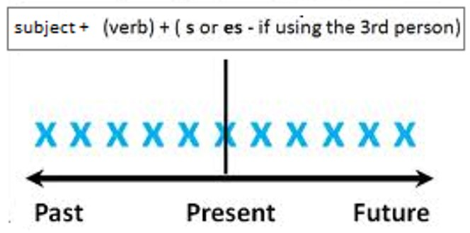
- concept and formation
The simple present tense indicates an action in the present time which is not finished. This tense is easy to conjugate because all terminations are the same except with the third person

We form the Simple present with the subject and the verb

- Uses of the Simple present
we use the simple present with:
Permanent states
This are states intended to exist or function for a long, indefinite period without regard to unforeseeable conditions
E.g.
she lives in Barcelona - He works at Teleperformance - She has two daughters –
She is married - I am Salvadorian

Repeated action
These are actions that are done with certain frequency, so we can identify or use the simple present by seeing or using the frequency adverbs. The following scale shows the adverbs and their level of frequency that they represent.
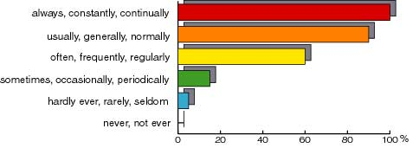
E.g. I often travel to Spain – I always go to the church – she rarely goes to the gym – she never sleeps in the afternoons

Habits
something that you do often and regularly, sometimes without knowing that you are doing it
E.g. she walks to work – She buys the same brand of shampoo – he exercises every afternoon, He works out biceps on Mondays and legs on Tuesdays

Daily routines
A daily routine is like a habit or sequence of activities that someone does during the day without any variation
E.g.
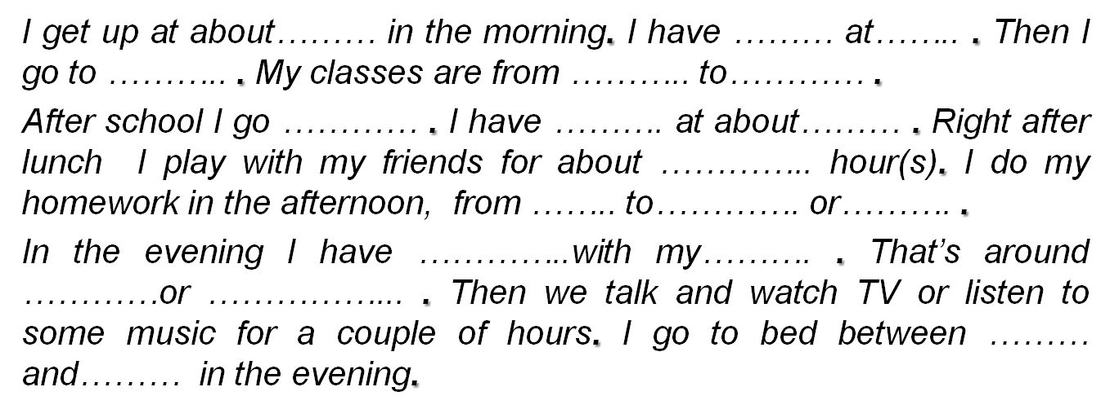

- Spelling of the third person singular

We form the third person singular (he, she, it) by adding “s” to the end of most verbs
E.g. I like – He Likes I eat- He eats

We add -es to the verbs that end in –ss, sh, -ch, -x, or -o
E.g. I miss – He Misses, I brush –He brushes, I teach – He teaches, I fix- He fixes, I do- He does

Verbs ending in consonant + y, drop the y and add –ies
E.g. I study- He studies You cry- He cries

Verbs ending in a vowel + y, take –s
E.g. I play- He plays, I stay- She stays

- Negative form
We form the third person singular negative with does not/doesn’t + main verb
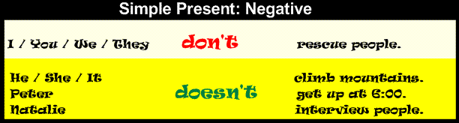
And we form all the other persons in the negative with do not/ don’t +main verb

- Interrogative form
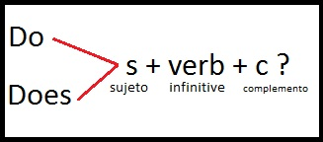
We form the third person singular in the interrogative with does + personal pronoun + main verb
And the other persons in the interrogative with do + personal pronoun + main verb

- Examples of how the simple present looks in its three forms
Conjugating the verb WORK

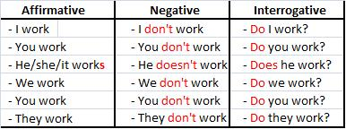

- In groups work in the exercises 1-6 from the grammar book blockbuster pages 93-95, using the rules provided
PRESENT PROGRESSIVE
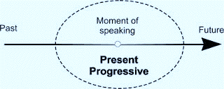
- Concept
The PRESENT PROGRESSIVE TENSE indicates continuing action, something going on now.

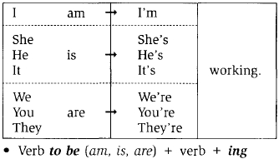
This tense is formed with the helping "to be" verb, in the present tense, plus the present participle of the verb (with an -ing ending)

Its structure in the negative and interrogative are:
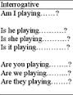
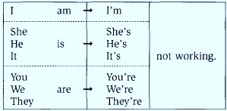

- Spelling
- Most of the verbs take –ing after the base form of the main verb
E.g. Play-playing, climb-climbing, count-counting
- Verbs ending in –e drop the –e and take ing
Ride-riding, make-making
- verbs ending in a vowel + consonant, double the consonant and take –ing
run-running, sit-sitting.

- Uses

resolve the following pictures using the rules provided 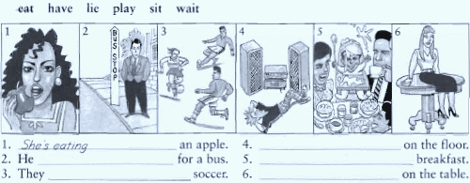
work on the exercises 1-7 from the grammar book blockbuster.

PRESENT PERFECT

- Concept
We use the Present Perfect to say that an action happened at an unspecified time before now. The exact time is not important. You CANNOT use the Present Perfect with specific time expressions such as: yesterday, one year ago, last week, when I was a child, when I lived in Japan, at that moment, that day, one day, etc. We CAN use the Present Perfect with unspecific expressions such as: ever, never, once, many times, several times, before, so far, already, yet, etc.

- Form

The present perfect is formed with the auxiliar verb "to have" in the present tense and the main verb in past participle, for the regular verbs it is just the simple form of the past.

Affirmative Sentences
Structure
Subjet + auxiliary verb ("to have") + past participle...
E.g. I've talked to Peter

Negative Sentences
Subjet + auxiliary verb ("to have") + not + past participle...
E.g. I haven't talked to Peter

Interrogative Sentences
Auxiliary verb (“to have”)+Subject + Past participle …
E.g.Have you talked to Peter?

- Uses

Experience
You can use the Present Perfect to describe your experience. It is like saying, "I have the experience of..." You can also use this tense to say that you have never had a certain experience. The Present Perfect is NOT used to describe a specific event.
Examples:
- I have been to France
- I think I have seen that movie before.
- He has never traveled by train.
- Joan has studied two foreign languages

Change Over Time
We often use the Present Perfect to talk about change that has happened over a period of time.

Examples:
- You have grown since the last time I saw you.
- The government has become more interested in arts education.
- Japanese has become one of the most popular courses at the university since the Asian studies program was established.
- My English has really improved since I moved to Australia.

Accomplishments
We often use the Present Perfect to list the accomplishments of individuals and humanity. You cannot mention a specific time.
Examples:
- Man has walked on the Moon.
- Our son has learned how to read.
- Doctors have cured many deadly diseases.
- Scientists have split the atom.

An Uncompleted Action You Are Expecting
We often use the Present Perfect to say that an action which we expected has not happened. Using the Present Perfect suggests that we are still waiting for the action to happen.
Examples:
- James has not finished his homework yet.
- Susan hasn't mastered Japanese, but she can communicate.
- Bill has still not arrived.
- The rain hasn't stopped.

Multiple Actions at Different Times
We also use the Present Perfect to talk about several different actions which have occurred in the past at different times. Present Perfect suggests the process is not complete and more actions are possible.
Examples:
- The army has attacked that city five times.
- I have had four quizzes and five tests so far this semester.
- We have had many major problems while working on this project.
- She has talked to several specialists about her problem, but nobody knows why she is sick.
PRESENT PERFECT CONTINUOUS

- Concept
The present perfect continuous refers to an unspecified time between 'before now' and 'now'. The speaker is thinking about something that started but perhaps did not finish in that period of time. He/she is interested in the process as well as the result, and this process may still be going on, or may have just finished.
- Form
The structure of the present perfect continuous tense is:
subject | + | auxiliary verb | + | auxiliary verb | + | main verb
 |  | have  has |  | been |  | base + ing

Affirmative Sentences
Structure
Subjet + auxiliary verb ("to have") + been + main verb +ing...
E.g. I've been talking to Peter

Negative Sentences
Subjet + auxiliary verb ("to have") + not + been+ main verb+ing...
E.g. I haven't been talking to Peter

Interrogative Sentences
Auxiliary verb (“to have”)+Subject + been + main verb + ing…
E.g. Have you been talking to Peter?

Here are some examples of the present perfect continuous tense:
 | subject | auxiliary verb |  | auxiliary verb | main verb
+ | I | have |  | been | waiting | for one hour.
+ | You | have |  | been | talking | too much.
- | It | has | not | been | raining.
- | We | have | not | been | playing | football.
? | Have | you |  | been | seeing | her?
? | Have | they |  | been | doing | their homework?

- Uses
This tense is called the present perfect continuous tense. There is usually a connection with the present or now. There are basically two uses for the present perfect continuous tense:

1. An action that has just stopped or recently stopped
We use the present perfect continuous tense to talk about an action that started in the past and stopped recently. There is usually a result now.
I'm tired because I've been running.
past | present | future
!!!

Recent action. | Result now.
- I'm tired ^{[now]} because I've been running.
- Why is the grass wet ^{[now]}? Has it been raining?
- You don't understand ^{[now]} because you haven't been listening.

2. An action continuing up to now
We use the present perfect continuous tense to talk about an action that started in the past and is continuing now. This is often used with for or since.

I have been reading for 2 hours.
past | present | future
Action started in past. | Action is continuing now.
- I have been reading for 2 hours. [I am still reading now.]
- We've been studying since 9 o'clock. [We're still studying now.]
- How long have you been learning English? [You are still learning now.]
- We have not been smoking. [And we are not smoking now.]

PRACTICE

Present Perfect / Present Perfect Continuous
Using the words in parentheses, complete the text below with the appropriate tenses
Principio del formulario
Robin: I think the waiter (forget) us. We (wait) here for over half an hour and nobody (take) our order yet.
Michele: I think you're right. He (walk) by us at least twenty times. He probably thinks we (order, already) .
Robin: Look at that couple over there, they (be, only) here for five or ten minutes and they already have their food.
Michele: He must realize we (order, not) yet! We (sit) here for over half an hour staring at him.
Robin: I don't know if he (notice, even) us. He (run) from table to table taking orders and serving food.
Michele: That's true, and he (look, not) in our direction once.
------------------------------------------------------------------------------------------------------

- Judy: How long (be) in Canada?
Claude: I (study) here for more than three years.
2. I (have) the same car for more than ten years. I'm thinking about buying a new one.
3. I (love) chocolate since I was a child. You might even call me a "chocoholic."
4. Matt and Sarah (have) some difficulties in their relationship lately, so they (go) to a marriage counselor. I hope they work everything out.
5. John (work) for the government since he graduated from Harvard University. Until recently, he (enjoy) his work, but now he is talking about retiring.
6. Lately, I (think) about changing my career because I (become) dissatisfied with the conditions at my company.
7. I (see) Judy for more than five years and during that time I (see) many changes in her personality.

